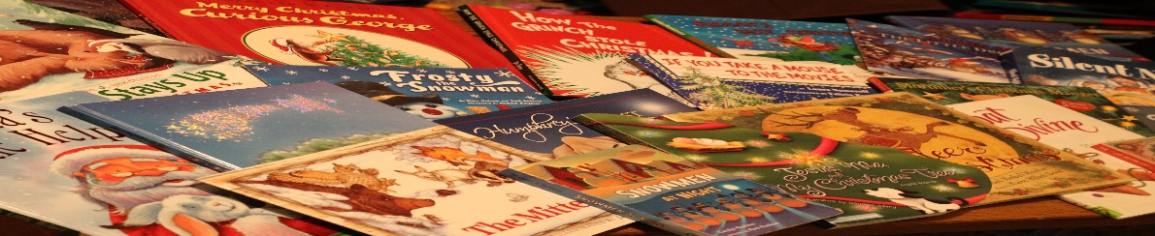
This Photo by Unknown Author is licensed under CC BY-SA-NC
READER PROFILE FOR KINDERGARDEN AND INFANTS: GETTING TO KNOW YOU
DEAR PARENTS, PLEASE HELP YOUR CHILD TO COMPLETE THIS PROFILE AND EMAIL IT TO MRS BEYERS AT:
library@stwinefridesircs.co.uk
Name and surname ...............................................................................Class ......................
Age ................
Do you listen to stories at home, read by a parent/grandparent/brother or sister/carer/?..............................
Do you enjoy listening to stories? Sometimes….......... often........... at bedtime .......... almost any time………
Are you an independent reader (reading a picture book or short /long chapter book without much help)?................
Do you find reading easy fun hard work boring ? Tick the boxes which best describe your reading, or write a sentence to describe how you feel about reading.
.........................................................................................................................................................................................
List some of the books you have listened to or read this year. If you can’t remember the author’s name and surname, just put the title of the book.
..........................................................................................................................................................................................
...........................................................................................................................................................................................
...........................................................................................................................................................................................
Who are your favourite authors?
..........................................................................................................................................................................................
What kind of books do you like best? A mystery, an adventure, a family story, an animal story, a school story, a ghost story, a story set in the real world, or another world, a story with magical beasts? Circle the ones you prefer. Or write a sentence or a few words describing the kind of books you like: ............................................................................................................................................................................................
Do you like stories that make you laugh..................or make you sad...............................? (tick)
Which sports are you interested in?
............................................................................................................................................................................................
What are your hobbies and interests?
............................................................................................................................................................................................
Do you have a favourite TV programme?...............What is it called? ...............................................................................
Thank you very much for completing this profile. Please keep on listening to stories and reading all sorts of books and comics – it’s a wonderful way to relax!
With kind regards from Mrs Beyers.

